**ACTORS**

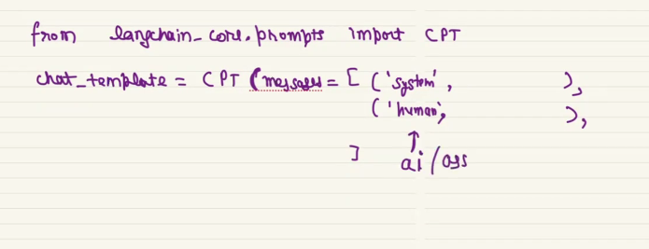

There can be many actor like AI, assistant in chat prompt template

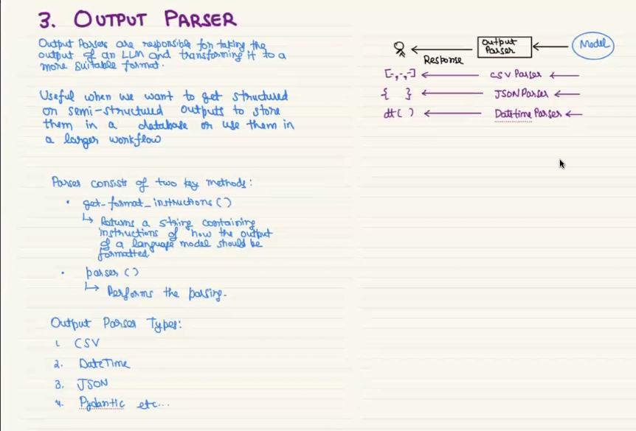

**COMMA SEPERATED OUTPUT PARSER**

Gives the output in list, it have the built in function called get_format_instruction() which actually gives the output in list

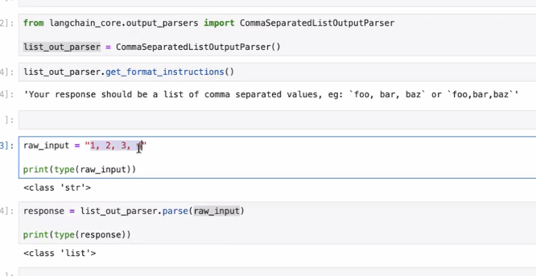

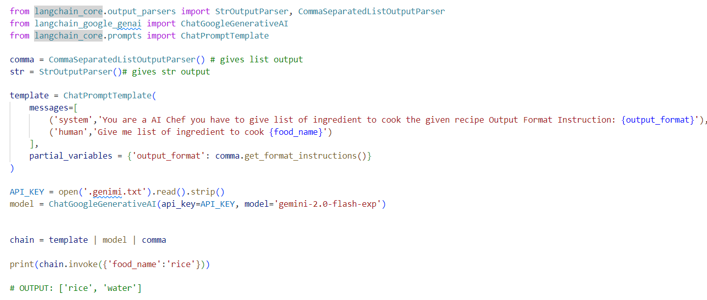

**JSON PARSER**

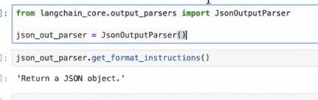

**DATE PARSER**

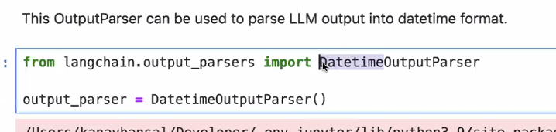

**CUSTOM OUTPUT PARSER**

